3GPP TSG-RAN WG4 Meeting#119 R4-2606886
Dalian, CN, May 18 - 22, 2026
Agenda item: 8.10.4
Source: ZTE Corporation, Sanechips
Title: Discussion on coexistence study and simulation assumptions for 6G sensing
Document for: Approval
- Introduction
In RAN#108 meeting, a new SID on Study on 6G Radio [1] was approved. In this contribution, we would like to share some further understandings on 6GR ISAC study.
- Sensing – Studies to be based on use cases and associated requirements, as defined in [TR38.914]
- PHY functions and procedures for sensing technology (e.g., waveform. reference signals, measurement feedback, etc…) [RAN1, RAN4]
- Evaluate sensing performance and if necessary, extend channel modelling, for the selected use cases [RAN1]
- Aspects of integration with communication services [RAN1]
- higher layer procedures and protocol aspects [RAN2]
- RAN4 aspects of sensing including RF, coexistence, and testability in coordination with other WGs [RAN4]
Note: RAN1 identify detailed requirements, if triggered by TSG RAN
RAN4#116bis:
Agreement:
Before April 2026, the agenda for sensing will be kept. RAN4 discussion will primarily focus on the following aspect
- Sensing related regulatory status and requirement survey
- Potential architecture consideration based on the RAN plenary use case study
- views sharing on the potential RAN4 scope based on the identified use cases out of RAN plenary study
- Identify less RAN1 design dependent RAN4 aspects if any

- Discussion

2.1. General for coexistence study for 6G sensing
In the previous RAN4 meetings, there were some discussions on coexistence study for 6G sensing, in the following Table 2.1-1, we summarized the coexistence cases and the motivation on such kind of coexistence study and whether the corresponding coexistence study could be omitted if the certain condition is met.
Table 2.1-1. Coexistence study for 6G sensing
Coexistence case | Aggressor | Victim | Remark
1 | 6G sensing | 6GR communication | if the transmitter of sensing signal regardless of TRP or UE can comply with IMT BS/UE requirements, then no coexistence study is expected.
2 | 6GR communication | 6G sensing | Coexistence study is needed since the impacts of 6GR adjacent channel leakage on sensing results are not clear, this needs the corresponding coexistence study.
3 | 6G sensing | 5G NR communication | if the transmitter of sensing signal regardless of TRP or UE can comply with IMT BS/UE requirements, then no coexistence study is expected.
4 | 5G NR communication | 6G sensing | Coexistence study is needed since the impacts of 5G adjacent channel leakage on sensing results are not clear, this needs the corresponding coexistence study.
5 | 6G sensing | 6G Sensing | Similar as coexistence 2.

Proposal 1: For coexistence study for 6G sensing, propose to consider the coexistence cases as listed in Table 2.1-1.
In addition, for the different use case of 6G sensing as mentioned in section 2.1, the deployment is expected to be different. During the last RAN1#124bis meeting, RAN1 reached the following consensus for different sensing target and corresponding scenarios. From RAN4 coexistence evaluation perspective, RAN4 should also align with RAN1 evaluation assumption as following.
Agreement:
For Rel-20 6G sensing performance evaluation of object detection and/or tracking, the following cases/combinations are considered as baseline cases/combinations.
Sensing target | Indoor or outdoor | Scenario | Carrier frequency
UAV | Outdoor | UMa-AV, SMa | 4 GHz, ~7 GHz, 30 GHz (for UMa-AV only)
Human | Outdoor | UMa | 4 GHz, ~7 GHz, 30 GHz
 | Indoor | Indoor Hotspot | 4 GHz, ~7 GHz, 30 GHz
Vehicle | Outdoor | Urban Grid, Highway | 4 GHz, ~7 GHz, 30 GHz (for Urban Grid only)
AGV | Indoor | Indoor factory (SH) | 4 GHz, ~7 GHz, 30 GHz

From RAN4 coexistence evaluation perspective, RAN4 should also align with RAN1 evaluation assumption as following Table 2.1-2.
Table 2.1-2. the potential deployment for different ISAC use case
Use case | Deployment | Carrier frequency
UAV detection and tracking including both mono-static and bi-static | UMa-AV, SMa | 4 GHz, ~7 GHz, 30 GHz (for UMa-AV only)
Vehicle detection and tracking | Urban Grid, Highway | 4 GHz, ~7 GHz, 30 GHz (for Urban Grid only)
Proposal 2: For the use case and sensing mode, propose to consider the above deployment scenario for coexistence study and further discuss the down-selection on the deployment e.g. pick up one of two deployment scenarios.

2.2.Coexistence case for 6G TRP mono-static sensing mode
Since the 6G sensing system is designed as technology solution with different measurement metric compared with the legacy wireless communication system, in general, the appropriate coexistence study is needed to guarantee the coexistence with the legacy communication system and new ISAC system.
As shown in the following Figure 2.2-1/2 for ISAC BS with solution 1/2 implementation, the coexistence studies between ISAC system and legacy communication system should be considered in 6G SI phase.
In addition, ISAC system coexisting with ISAC system in the adjacent channel should be also considered similar to Rel-20 SBFD coexisting with SBFD.
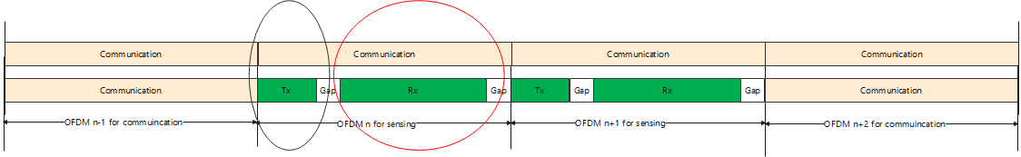
Figure 2.2-1. Co-existence case for ISAC BS with option 1 assumption [similar to SBFD co-existence study]
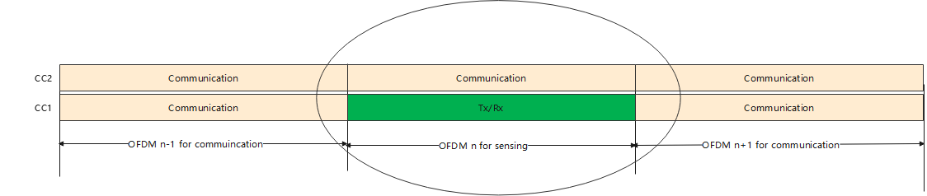
Figure 2.2-2. Co-existence case for ISAC BS with option 2 assumption [similar to SBFD co-existence study]
Proposal 3: For the TRP mono-static, the coexistence studies between 6G sensing and the legacy system need to be conducted to figure out the appropriate RF requirements.

2.2.1.Coexistence case
In the following Table 2.2.1-1, we provide some initial understanding on the potential coexistence cases for 6G sensing study in RAN4.
Table 2.2.1-1. The potential coexistence case for TRP mono-static sensing mode
Scenario | FR | Aggressor | Victim
1A | 4GHz | 6G sensing | 5G communication
2A | 4GHz | 5G communication | 6G sensing
3A | 7GHz | 6G sensing | 5G communication
4A | 7GHz | 5G communication | 6G sensing
5A | 30GHz | 6G sensing | 5G communication
6A | 30GHz | 5G communication | 6G sensing
Note 1: More scenarios could be added based on the consensus in RAN1/4.

In the following Table 2.2.1-2, we provide some initial analysis on adjacent channel interference for 6G sensing study from both TRP mono-static implementation.
Table 2.2.1-2: Adjacent channel co-existence cases for TRP mono-static deployment
Case | Aggressor | Aggressor baseline | Victim | Remarks
1 | ISAC | TDD DL | TDD DL | Option 1:  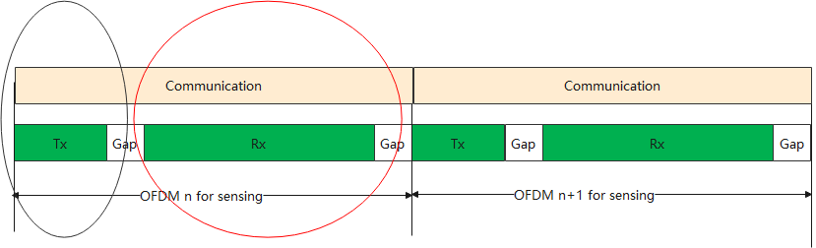  Option 2:  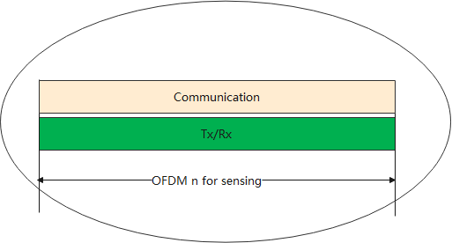  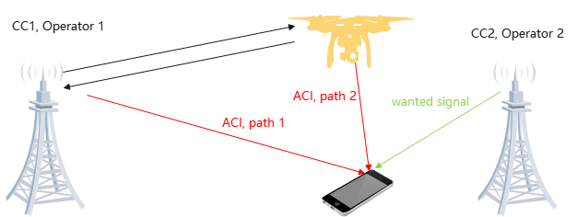  Observation 1: For 6G sensing TRP interfering 6GR DL, if the sensing TRP can comply with 6GR BS requirements, then the coexistence performance between 6G sensing and 6G communication or 5G communication can be guaranteed.
2 | TDD DL | No aggressor network | ISAC | 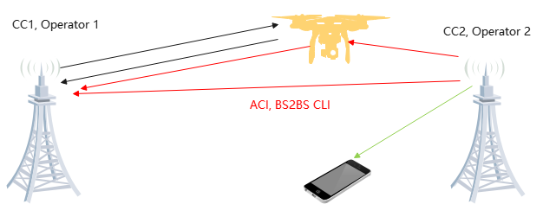  Observation 2: For 6GR DL interfering 6GR sensing, the BS2BS CLI including reflected path and non-reflected path should be considered for the TRP monostatic with two implementation schemes.
3 | ISAC | No aggressor network | ISAC | 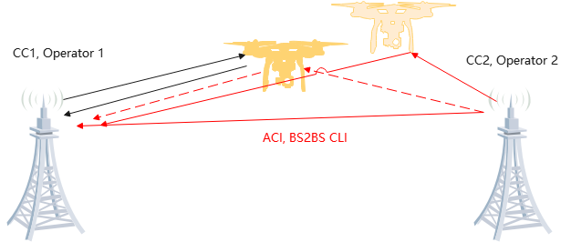  Observation 3: For 6GR sensing interfering 6GR sensing, the BS2BS CLI should be considered for the TRP monostatic with the implementation option 1 at least;  Observation 4: For 6GR sensing interfering 6GR sensing, the BS2BS CLI is not considered for the TRP monostatic with the implementation option 2 if TDM sensing pattern are aligned from the different carriers;
NOTE: assume the ISAC to be deployed in the DL symbols to ensure the coverage as 1st priority

2.2.2.Simulation assumption for coexistence study
In the previous RAN1#122 and RAN1#122bis meeting as captured in the running summary for 6G sensing, RAN1 has already reached the following agreement on 5G-A sensing evaluation assumption. From RAN4 sensing coexistence evaluation, we propose to agree the following simulation assumptions to conduct the initial coexistence study.
The following evaluation parameters are agreed for the evaluation on NR ISAC.
Parameters | Assumptions
Scenario | UMa-AV
Carrier frequency | 4 GHz, 7GHz and 30GHz
System bandwidth | 100 MHz for 4GHz and 7GHz  200MHz for 30GHz
Numerology | SCS = 30kHz for 4GHz and 7GHz  SCS=120kHz for 30GHz
BS Layout | 19 sites with 57 sectors
Inter-BS (2D) distance | Uma-AV: 500m for FR1  Uma-AV: 200m for FR2
BS antenna height | 25m for UMa-AV
Wrap-round | wrap-round
Note1: target(s) are dropped only in the center site, and inter-BS interference is not modelled.

The following evaluation parameters are agreed for the evaluation on NR ISAC.
Parameters | Assumptions
Target type | UAV with small size (0.3m x 0.4m x 0.2m)
Target distribution when target(s) are dropped | N = 5 targets per sector in the center site.  Optional: N is uniformly distributed from 1 to 10.  Horizontal plane: uniformly distributed in a sector  Vertical plane: Uniformly distributed between 25m and 300m, optionally distributed between 1.5m and 300m
Mobility | horizontal speed: uniformly distributed between 0 and 180km/h  vertical speed: 0km/h
Note: N=0 will be discussed in a later proposal in relation to false alarm.

The following evaluation parameters are agreed for the evaluation on NR ISAC.
Parameters | Assumptions
Minimum BS-target 3D distance | 35 m
Minimum target-target (3D) distance | 10 m
Target outdoor/indoor proportion | 100% outdoor
LOS/NLOS | LOS and NLOS
Orientation | Random in horizontal domain

The following evaluation parameters are agreed for the evaluation on 6GR ISAC.
Parameters | Assumptions
BS antenna configuration | For 4GHz  - Implementation option 1 [TDM]  - Tx: (12,8, 2,1,1;4,8)  - Rx: (12,8, 2,1,1;4,8)  - Implementation option 2 [Full duplex]  - Tx: (6,8, 2,1,1;2,8)  - Rx: (6,8, 2,1,1;2,8) | For 7GHz:  - Implementation option 1 [TDM]  - Tx: (24,16, 2,1,1;8,16)  - Rx: (24,16, 2,1,1;8,16)  - Implementation option 2 [Full duplex]  - Tx: (12,16, 2,1,1;4,16)  - Rx: (12,16, 2,1,1;4,16)
 | For 30GHz  - Implementation option 1 [TDM]  - Tx: (12,8, 2,1,1;4,8)  - Rx: (12,8, 2,1,1;4,8)  - Implementation option 2 [Full duplex]  - Tx: (6,8, 2,1,1;2,8)  - Rx: (6,8, 2,1,1;2,8) | SBFD config 2 (baseline): (Mg,Ng,M,N,P)=(1,1,8,16,2)  (d_{H},d_{V})=(0.5,0.5)λ
 | Mandatory: $\left(d_{H},d_{V}\right)$ = (0.5, 0.7)λ, two polarization
Note: Tx antenna elements and Rx antenna elements are operating simultaneously

The following evaluation parameters are agreed for the evaluation on NR ISAC.
Parameters | Assumptions
BS antenna radiation pattern | clause 7.1.3 as captured in TR 38.922
BS antenna mechanic tilt | Without mechanical tilt for UAV detection
BS antenna sub-array fixed tilt | 3 degree per sub-array

The following evaluation parameters are agreed for the evaluation on NR ISAC.
Parameters | Assumptions
gNB-target link | gNB-aerial UE of UMa parameters in 36.777 with Alternative 3
Concatenation of TX-target and target-RX links | Up to company choice between two options for concatenation defined in Step 9 in section 7.9.4.1, TR 38.901
The power threshold for path dropping after concatenation for target channel | -25dB and -40dB are respectively used for the two options for concatenation

When Tx/Rx operates simultaneously (baseline case), the following parameters are used for the evaluation on FR1 NR ISAC:
Antenna isolation for the implementation option 2 | - Option 1: 65dB  - Option 2: 80dB
Maximum BS Tx power for FR1 | - Option 1: 37dBm for the implementation option 2 [Full duplex]  - Option 2: 52dBm for the implementation option 1[TDM]  The above options are calculated with BS_maxpower = BS Rx saturation power + antenna isolation by assuming the BS Rx saturation power = -28dBm and the antenna isolation = 65dB and 80dB, respectively
- Optionally: companies should report the maximum BS Tx power when it is assumed that Tx and Rx don’t operate simultaneously. Companies should report how the maximum BS Tx power is derived.
Antenna isolation for the implementation option 2 | - Option 1: TBD  - Option 2: TBD
Maximum BS Tx power for FR2 | - Option 1: 30dBm for the implementation option 2 [Full duplex]  - Option 2: 30Bm for the implementation option 1[TDM]  The above options are calculated with BS_maxpower = BS Rx saturation power + antenna isolation by assuming the BS Rx saturation power = -28dBm and the antenna isolation = 65dB and 80dB, respectively

Agreement
When Tx/Rx operates simultaneously, the following evaluation parameters are agreed for the evaluation on NR ISAC.
Self-interference | The residual leakage interference/noise is modelled as X dB below the noise floor.ce

The following evaluation parameters are agreed for the evaluation on NR ISAC.
Parameters | Assumptions
Co-site inter-sector interference | Assumed to be same as intra-sector
Adjacent channel interference | Flat ACIR modelling
BS receiver noise figure | 5dB for FR1  10dB for FR2-1S

Proposal 4: for the simulation assumption for UAV sensing evaluation in RAN4, propose to use the above simulation assumptions for 6G sensing coexistence study.
Proposal 5: for the simulation assumption for TN BS, propose to follow the simulation assumption as captured in TR 38.922 for FR1 TDD network and TR 38.858 for FR2 TDD network.
In addition, in the previous RAN4 meeting, there were some proposals mentioning the RCS for sensing target. The modelling for RCS modelling is captured in clause 7.9.2.1 of TR 38.901. From RAN4 coexistence perspective, we could only consider the RCS in the large scale pathloss model as shown in the following table with two target path included.
Parameters | Values
Coupling loss for target channel | power scaling factor (pathloss, shadow fading, and RCS component $σ_{M}$ included):  $$L_{TX−SPST−RX}={PL}_{dB}\left(d_{1}\right)+{PL}_{dB}\left(d_{2}\right)+10lg\left(\frac{c^{2}}{4πf^{2}}\right)−10lg\left(σ_{RCS,A}\right)+{SF}_{dB,1}+{SF}_{dB,2}$$
STX/SRX selection | Best N = 4 STX-SRX pairs to be selected for the target.  see note 1
Metrics | Coupling loss for target channel  Coupling loss for background channel (in case of monostatic sensing, this is the coupling loss between Tx and one reference point)  see note 2
NOTE 1: Based on the STX-SRX pairs with the smallest power scaling factor of the target channel.
NOTE 2: CDFs can be separately generated for target channel, background channel.

Proposal 6: for the RCS of sensing target, propose to consider the RCS model as captured in clause 7.9.2.1 of TR 38.901 and simplify the RCS in the large scale pathloss model if necessary.

2.2.3. Methodology for ISAC coexistence study
Similar to other legacy coexistence study in the past, in order to quantify the performance impacts, we need to discuss the acceptable performance degradation for both ISAC and legacy system or 6GR communication system due to the adjacent channel leakage.
Proposal 7: For the UAV use case of 6G ISAC study at least, propose to consider the distance, angle estimation and velocity estimation as the basic metric for the study in RAN4.
Proposal 8: For the UAV use case of 6G ISAC study at least, propose to consider the distance accuracy impacts, angle estimation accuracy impacts and velocity estimation accuracy impacts to quantify the performance impacts from both co-channel and adjacent channel.
Proposal 9: for the 6G ISAC coexistence study in RAN4, for 6GR performance metric, propose to use the legacy throughput loss as basic metric.

2.3.Coexistence case for 6G TRP-TRP bistatic sensing mode
As shown in the following Figure 2.3.1 for 6G ISAC with bi-static sensing mode, the coexistence studies between ISAC system and legacy communication system should be considered in 6G SI phase.
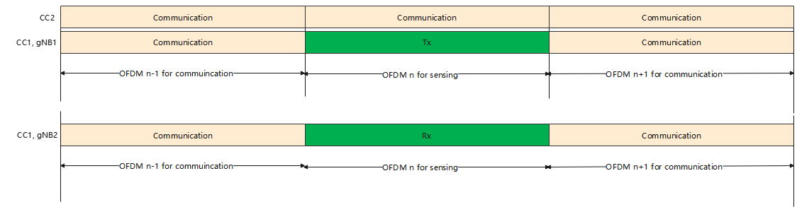
Figure 2.3-1. Coexistence case for 6G TRP bi-static sensing mode [similar as dynamic TDD]

2.3.1.Coexistence case
In the following Table 2.3.1-1, we provide some initial understanding on the potential coexistence cases for 6G sensing study in RAN4.
Table 2.3.1-1. The potential coexistence case for TRP bistatic sensing mode
Scenario | FR | Aggressor | Victim
1B | 4GHz | 6G sensing | 5G communication
2B | 4GHz | 5G communication | 6G sensing
3B | 7GHz | 6G sensing | 5G communication
4B | 7GHz | 5G communication | 6G sensing
5B | 30GHz | 6G sensing | 5G communication
6B | 30GHz | 5G communication | 6G sensing
Note 1: More scenarios could be added based on the consensus in RAN1/4.

In the following Table 2.2.1-2, we provide some initial analysis on adjacent channel interference for 6G sensing study from both TRP mono-static implementation.
Table 2.3.1-2: Adjacent channel co-existence cases for TRP bi-static deployment
Case | Aggressor | Aggressor baseline | Victim | Remarks
4 | ISAC | TDD DL | TDD DL |   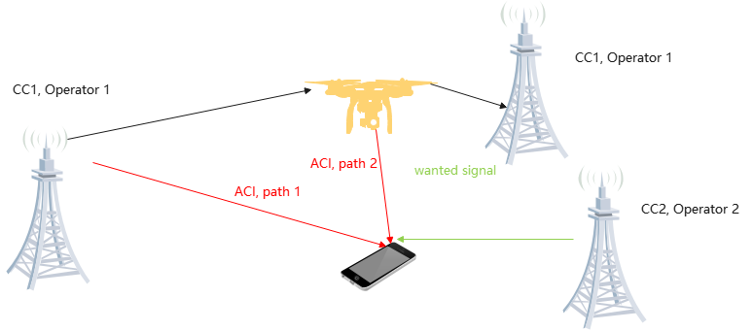  Observation 1: For 6G sensing TRP interfering 6GR communication DL, if the sensing TRP can comply with 6GR BS requirements, then the coexistence performance between 6G sensing and 6G communication or 5G communication can be guaranteed.
5 | TDD DL | No aggressor network | ISAC | 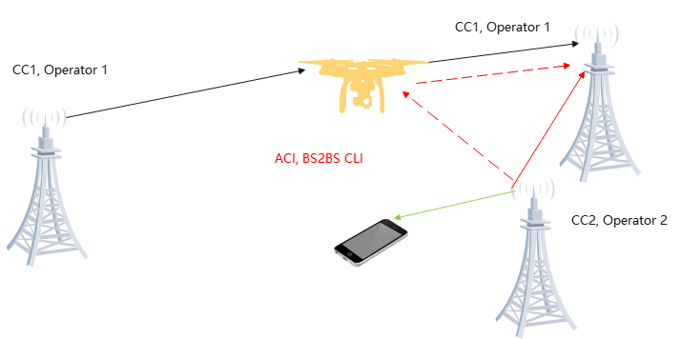  Observation 2: For 6GR communication DL interfering 6GR sensing, the BS2BS CLI including reflected path and non-reflected path should be considered for the TRP bi-static.
6 | ISAC | No aggressor network | ISAC | 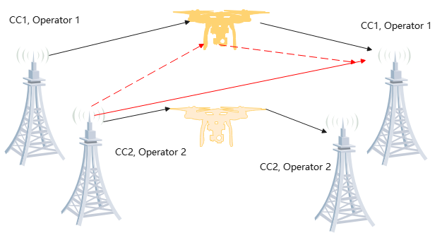  Observation 3: For 6GR sensing interfering 6GR sensing, the BS2BS CLI should be considered for the TRP bi-static.
NOTE: assume the ISAC to be deployed in the DL symbols to ensure the coverage as 1st priority

2.3.2.Simulation assumption for coexistence study
Regarding the simulation assumption for 6GR TRP bi-static sensing mode, the simulation assumption could be the same as 6GR mono-static sensing mode with the implementation option 1 [TDM manner].
Proposal 10: for the simulation assumption for UAV sensing evaluation in RAN4, propose to use the same simulation assumption as 6GR mono-static sensing mode with the implementation option 1 [TDM manner].

2.3.3. Methodology for ISAC coexistence study
Regarding the simulation methodology for 6GR TRP bi-static sensing mode, the simulation methodology could be the same as 6GR mono-static sensing mode with the implementation option 1 [TDM manner].
Proposal 11: for the simulation methodology for 6G TRP with bi-static sensing mode, propose to use the same simulation methodology as 6GR mono-static sensing mode.

2.4.Coexistence case for 6G TRP-UE bistatic sensing mode
As shown in the following Figure 2.4.1-1 for 6G ISAC with bi-static sensing mode, the coexistence studies between ISAC system and legacy communication system should be considered in 6G SI phase.
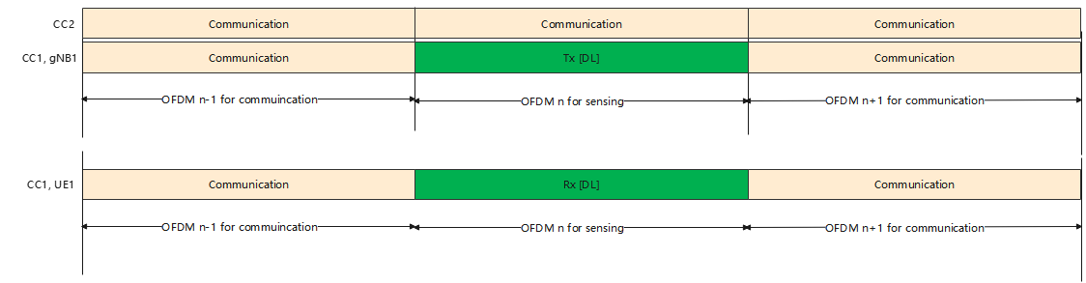
Figure 2.4.1-1. Coexistence case for 6G TRP-UE bi-static sensing mode

2.4.1.Coexistence case
In the following Table 2.4.1-1, we provide some initial understanding on the potential coexistence cases for 6G sensing study in RAN4.
Table 2.4.1-1. The potential coexistence case for TRP-UE bistatic sensing mode
Scenario | FR | Aggressor | Victim
1C | 4GHz | 6G sensing | 5G communication
2C | 4GHz | 5G communication | 6G sensing
3C | 7GHz | 6G sensing | 5G communication
4C | 7GHz | 5G communication | 6G sensing
5C | 30GHz | 6G sensing | 5G communication
6C | 30GHz | 5G communication | 6G sensing
Note 1: More scenarios could be added based on the consensus in RAN1/4.

In the following Table 2.4.1-2, we provide some initial analysis on adjacent channel interference for 6G sensing study from both TRP mono-static implementation.
Table 2.4.1-2: Adjacent channel co-existence cases for TRP-UE bi-static deployment
Case | Aggressor | Aggressor baseline | Victim | Remarks
4 | ISAC | TDD DL | TDD DL |   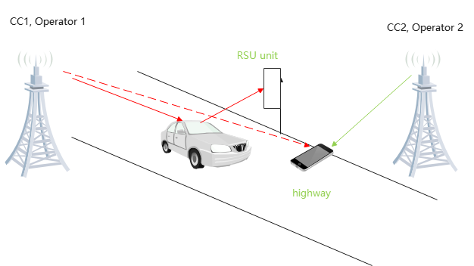  Observation 1: For 6G sensing TRP interfering 6GR communication in DL, if the sensing TRP can comply with 6GR BS requirements, then the coexistence performance between 6G sensing and 6G communication or 5G communication can be guaranteed.
5 | TDD DL | No aggressor network | ISAC | 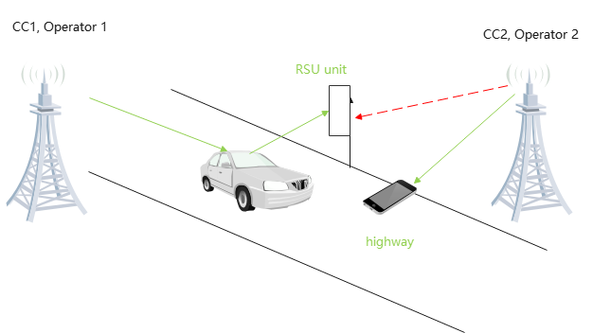  Observation 2: For 6GR communication DL interfering 6GR sensing, the BS2UE ACI should be considered for TRP-UE bi-static sensing mode.
6 | ISAC | No aggressor network | ISAC | 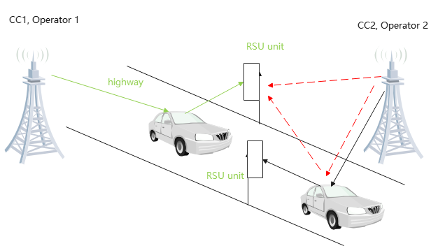  Observation 3: For 6GR sensing interfering 6GR sensing, the BS2UE ACI should be considered for the TRP-UE bi-static sensing mode.
NOTE: assume the ISAC to be deployed in the DL symbols to ensure the coverage as 1st priority

2.4.2.Simulation assumption for coexistence study
Regarding the simulation assumption for 6GR TRP-UE bi-static sensing mode, the simulation assumption could be the same as 6GR mono-static sensing mode with the implementation option 1 [TDM manner].
Proposal 12: for the simulation assumption for TRP-UE sensing evaluation in RAN4, propose to use the same simulation assumption as 6GR mono-static sensing mode with the implementation option 1 [TDM manner].

2.3.3. Methodology for ISAC coexistence study
Regarding the simulation methodology for 6GR TRP bi-static sensing mode, the simulation methodology could be the same as 6GR mono-static sensing mode with the implementation option 1 [TDM manner].
Proposal 13: for the simulation methodology for 6G TRP-UE with bi-static sensing mode, propose to use the same simulation methodology as 6GR mono-static sensing mode.

2.5.Coexistence case for 6G UE-TRP bistatic sensing mode
In the following Table 2.5.1-1, we provide some initial understanding on the potential coexistence cases for 6G sensing study in RAN4.
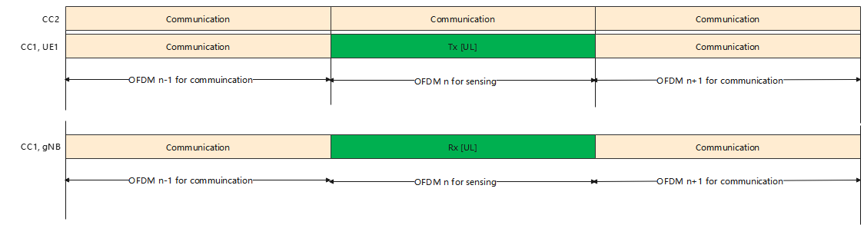
Figure 2.5.1-1. Coexistence case for 6G UE-TRP bi-static sensing mode

2.5.1.Coexistence case
In the following Table 2.4.1-1, we provide some initial understanding on the potential coexistence cases for 6G sensing study in RAN4.
Table 2.4.1-1. The potential coexistence case for TRP-UE bistatic sensing mode
Scenario | FR | Aggressor | Victim
1D | 4GHz | 6G sensing | 5G communication
2D | 4GHz | 5G communication | 6G sensing
3D | 7GHz | 6G sensing | 5G communication
4D | 7GHz | 5G communication | 6G sensing
5D | 30GHz | 6G sensing | 5G communication
6D | 30GHz | 5G communication | 6G sensing
Note 1: More scenarios could be added based on the consensus in RAN1/4.

In the following Table 2.4.1-2, we provide some initial analysis on adjacent channel interference for 6G sensing study from both TRP mono-static implementation.
Table 2.4.1-2: Adjacent channel co-existence cases for TRP bi-static deployment
Case | Aggressor | Aggressor baseline | Victim | Remarks
4 | ISAC | TDD DL | TDD DL |   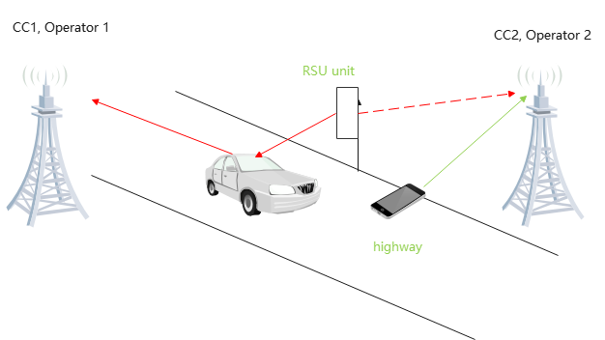  Observation 1: For 6G sensing TRP interfering 6GR communication in DL, if the sensing TRP can comply with 6GR UE requirements, then the coexistence performance between 6G sensing and 6G communication or 5G communication can be guaranteed.
5 | TDD DL | No aggressor network | ISAC | 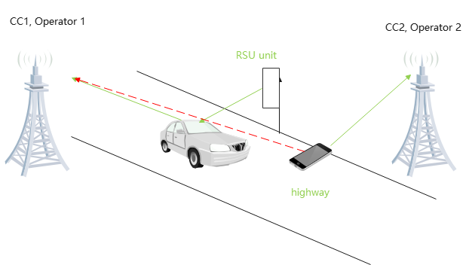  Observation 2: For 6GR communication UL interfering 6GR UE-TRP bi-static sensing mode, the UE2BS ACI should be considered.
6 | ISAC | No aggressor network | ISAC | 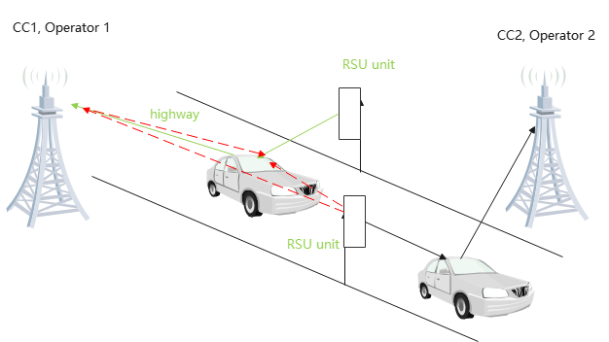  Observation 3: For 6GR sensing UL interfering 6GR UE-TRP bi-static sensing mode, the UE2BS ACI should be considered.
NOTE: assume the ISAC to be deployed in the DL symbols to ensure the coverage as 1st priority

2.5.2.Simulation assumption for coexistence study
Regarding the simulation assumption for 6GR TRP-UE bi-static sensing mode, the simulation assumption could be the same as 6GR mono-static sensing mode with the implementation option 1 [TDM manner].
Proposal 14: for the simulation assumption for UE-TRP bi-static sensing evaluation in RAN4, propose to use the same simulation assumption as 6GR mono-static sensing mode with the implementation option 1 [TDM manner].

2.5.3. Methodology for ISAC coexistence study
Regarding the simulation methodology for 6GR TRP bi-static sensing mode, the simulation methodology could be the same as 6GR mono-static sensing mode with the implementation option 1 [TDM manner].
Proposal 15: for the simulation methodology for 6G UE-TRP with bi-static sensing mode, propose to use the same simulation methodology as 6GR mono-static sensing mode.
- Conclusions
In this contribution, we shared some initial views on the 6GR ISAC study and proposals are made as follows:
General:
Proposal 1: For coexistence study for 6G sensing, propose to consider the coexistence cases as listed in Table 2.1-1.
Coexistence case | Aggressor | Victim | Remark
1 | 6G sensing | 6GR communication | if the transmitter of sensing signal regardless of TRP or UE can comply with IMT BS/UE requirements, then no coexistence study is expected.
2 | 6GR communication | 6G sensing | Coexistence study is needed since the impacts of 6GR adjacent channel leakage on sensing results are not clear, this needs the corresponding coexistence study.
3 | 6G sensing | 5G NR communication | if the transmitter of sensing signal regardless of TRP or UE can comply with IMT BS/UE requirements, then no coexistence study is expected.
4 | 5G NR communication | 6G sensing | Coexistence study is needed since the impacts of 5G adjacent channel leakage on sensing results are not clear, this needs the corresponding coexistence study.
5 | 6G sensing | 6G Sensing | Similar as coexistence 2.
Proposal 2: For the use case and sensing mode, propose to consider the above deployment scenario for coexistence study and further discuss the down-selection on the deployment e.g. pick up one of two deployment scenarios.
Use case | Deployment | Carrier frequency
UAV detection and tracking including both mono-static and bi-static | UMa-AV, SMa | 4 GHz, ~7 GHz, 30 GHz (for UMa-AV only)
Vehicle detection and tracking | Urban Grid, Highway | 4 GHz, ~7 GHz, 30 GHz (for Urban Grid only)

Proposal 3: For the TRP mono-static, the coexistence studies between 6G sensing and the legacy system need to be conducted to figure out the appropriate RF requirements.

For TRP mono-static sensing mode:
Table 2.2.1-2: Adjacent channel co-existence cases for TRP mono-static deployment
Case | Aggressor | Aggressor baseline | Victim | Remarks
1 | ISAC | TDD DL | TDD DL | Observation 1: For 6G sensing TRP interfering 6GR DL, if the sensing TRP can comply with 6GR BS requirements, then the coexistence performance between 6G sensing and 6G communication or 5G communication can be guaranteed.
2 | TDD DL | No aggressor network | ISAC | Observation 2: For 6GR DL interfering 6GR sensing, the BS2BS CLI including reflected path and non-reflected path should be considered for the TRP monostatic with two implementation schemes.
3 | ISAC | No aggressor network | ISAC | Observation 3: For 6GR sensing interfering 6GR sensing, the BS2BS CLI should be considered for the TRP monostatic with the implementation option 1 at least;  Observation 4: For 6GR sensing interfering 6GR sensing, the BS2BS CLI is not considered for the TRP monostatic with the implementation option 2 if TDM sensing pattern are aligned from the different carriers;
NOTE: assume the ISAC to be deployed in the DL symbols to ensure the coverage as 1st priority
Proposal 4: for the simulation assumption for UAV sensing evaluation in RAN4, propose to use the above simulation assumptions for 6G sensing coexistence study.
Proposal 5: for the simulation assumption for TN BS, propose to follow the simulation assumption as captured in TR 38.922 for FR1 TDD network and TR 38.858 for FR2 TDD network.
Proposal 6: for the RCS of sensing target, propose to consider the RCS model as captured in clause 7.9.2.1 of TR 38.901 and simplify the RCS in the large scale pathloss model if necessary.
Proposal 7: For the UAV use case of 6G ISAC study at least, propose to consider the distance, angle estimation and velocity estimation as the basic metric for the study in RAN4.
Proposal 8: For the UAV use case of 6G ISAC study at least, propose to consider the distance accuracy impacts, angle estimation accuracy impacts and velocity estimation accuracy impacts to quantify the performance impacts from both co-channel and adjacent channel.
Proposal 9: for the 6G ISAC coexistence study in RAN4, for 6GR performance metric, propose to use the legacy throughput loss as basic metric.

For TRP bi-static sensing mode:
Table 2.3.1-2: Adjacent channel co-existence cases for TRP bi-static deployment
Case | Aggressor | Aggressor baseline | Victim | Remarks
4 | ISAC | TDD DL | TDD DL | Observation 1: For 6G sensing TRP interfering 6GR communication DL, if the sensing TRP can comply with 6GR BS requirements, then the coexistence performance between 6G sensing and 6G communication or 5G communication can be guaranteed.
5 | TDD DL | No aggressor network | ISAC | Observation 2: For 6GR communication DL interfering 6GR sensing, the BS2BS CLI including reflected path and non-reflected path should be considered for the TRP bi-static.
6 | ISAC | No aggressor network | ISAC | Observation 3: For 6GR sensing interfering 6GR sensing, the BS2BS CLI should be considered for the TRP bi-static.
NOTE: assume the ISAC to be deployed in the DL symbols to ensure the coverage as 1st priority
Proposal 10: for the simulation assumption for UAV sensing evaluation in RAN4, propose to use the same simulation assumption as 6GR mono-static sensing mode with the implementation option 1 [TDM manner].
Proposal 11: for the simulation methodology for 6G TRP with bi-static sensing mode, propose to use the same simulation methodology as 6GR mono-static sensing mode.

For TRP-UE bi-static sensing mode:
Table 2.4.1-2: Adjacent channel co-existence cases for TRP-UE bi-static deployment
Case | Aggressor | Aggressor baseline | Victim | Remarks
4 | ISAC | TDD DL | TDD DL | Observation 1: For 6G sensing TRP interfering 6GR communication in DL, if the sensing TRP can comply with 6GR BS requirements, then the coexistence performance between 6G sensing and 6G communication or 5G communication can be guaranteed.
5 | TDD DL | No aggressor network | ISAC | Observation 2: For 6GR communication DL interfering 6GR sensing, the BS2UE ACI should be considered for TRP-UE bi-static sensing mode.
6 | ISAC | No aggressor network | ISAC | Observation 3: For 6GR sensing interfering 6GR sensing, the BS2UE ACI should be considered for the TRP-UE bi-static sensing mode.
NOTE: assume the ISAC to be deployed in the DL symbols to ensure the coverage as 1st priority

Proposal 12: for the simulation assumption for TRP-UE sensing evaluation in RAN4, propose to use the same simulation assumption as 6GR mono-static sensing mode with the implementation option 1 [TDM manner].
Proposal 13: for the simulation methodology for 6G TRP-UE with bi-static sensing mode, propose to use the same simulation methodology as 6GR mono-static sensing mode.

For UE-TRP bi-static sensing mode:
Table 2.4.1-2: Adjacent channel co-existence cases for TRP bi-static deployment
Case | Aggressor | Aggressor baseline | Victim | Remarks
4 | ISAC | TDD DL | TDD DL | Observation 1: For 6G sensing TRP interfering 6GR communication in DL, if the sensing TRP can comply with 6GR UE requirements, then the coexistence performance between 6G sensing and 6G communication or 5G communication can be guaranteed.
5 | TDD DL | No aggressor network | ISAC | Observation 2: For 6GR communication UL interfering 6GR UE-TRP bi-static sensing mode, the UE2BS ACI should be considered.
6 | ISAC | No aggressor network | ISAC | Observation 3: For 6GR sensing UL interfering 6GR UE-TRP bi-static sensing mode, the UE2BS ACI should be considered.
NOTE: assume the ISAC to be deployed in the DL symbols to ensure the coverage as 1st priority

Proposal 14: for the simulation assumption for UE-TRP bi-static sensing evaluation in RAN4, propose to use the same simulation assumption as 6GR mono-static sensing mode with the implementation option 1 [TDM manner].
2.5.3. Methodology for ISAC coexistence study
Proposal 15: for the simulation methodology for 6G UE-TRP with bi-static sensing mode, propose to use the same simulation methodology as 6GR mono-static sensing mode.
- References
- RP-251881,New SID: Study on 6G Radio, Approved.
- RP-251742, Study on 6G scenarios and requirements - ISAC, ZTE,
- R1-2506131,Discussion on 5G-A ISAC evaluation,ZTE, Noted.
- RP-252024 RAN KPIs for IMT-2030
- R4-2602286 WF on 6G sensing, approved.

